Networking Trends Paper

Mohammed Faisal Ahmed

Data Communications and Networking

Prof. Salb James

10/15/2016

**Introduction**

The area of networking is one of those areas that are changing very fast with related services as well as applications that have an enormous and almost immediate effect on various aspects of the today’s society such as inter-human relations, education, economy, and entertainment. The networks are becoming more complex and are extending towards ubiquitous communications, as they also offer a broad range of other services as well as applications, from remote management of an intelligent system to sophisticated real-time navigation systems. There are several areas in which the network management and design has greatly advanced over the years since the inception of networks. Among the areas of network design and management include the areas of virtualization, security, hardware, network management tools, software defined networking, and wireless. In this paper, three areas that have greatly advanced about network design and management are discussed and these include virtualization, hardware, network management tools.

**Network Management Tools**

Not only is the Internet being used to accommodate more and more things, but also the data files being transferred across networks are becoming bigger and bigger each day. As the switches are being leveraged to link devices together on a network, and the data that is being transferred between those devices is growing regarding volume, newer switches have the capability of processing higher volumes of data (Xia et al., 2015). The switches that can only handle very low volumes of data are being eliminated by their successors that have more capabilities so as to drive the business performance to higher heights. That has necessitated the designers to have a backup switch for every port. Cisco Systems Inc. has also developed excellent business-grade solutions with the potential of performing automatic as well as proactive updates and virus scans, a solution that has eliminated the need to carry out manual updates and scans.

The advancements in the networking design and management have necessitated further development, and this has made this field continue thriving. Apart from the area of switches that has been discussed above, there has also been advancement in other areas of the network management tools. It is now possible to incorporate servers, software as well as applications and content into networks thereby arousing the need for an elastic model of network elements as well as network services. We can also witness an increased use of computer technologies that are leveraged in hosting content and applications. That increased utilization of this computer technology has played an imperative role in the shaping network managements. Such advancements in networks support the vision of having the future network management systems that are not only based on NMS but also have the basis of the computer as well as network management system software.

**Virtualization**

In the area of network virtualization, the developers have made great strides especially in the area of cloud-based technologies and Software-Defined Networking. It can be observed that more than half of organizations’ IT spending is going to the third Platform that is otherwise called cloud-based technologies, and, according to IDC, that figure will exceed 60 percent of all the spending on IT by the year 2020. We have observed the migration of the old, legacy IP network systems and infrastructure to New IP networks that has, in turn, accelerated, reaching near-mainstream adoption as also the organizations and service providers are continually transforming their networks into an open as well as a software-driven platform that fosters innovation and competitiveness. Below is the demonstration of desired future state of network virtualization.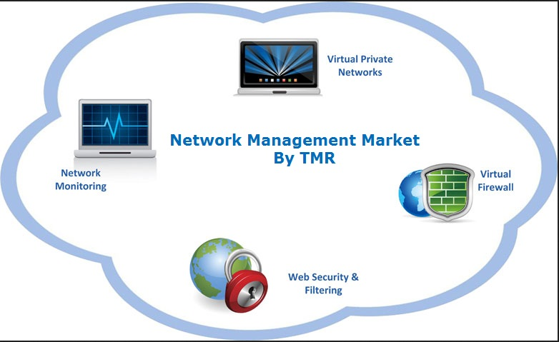

Over the past year 2015, software has greatly transformed the data center plus the networks in general. That can be observed from the fact that service providers and enterprises have turned to Software-Defined Networking (SDN) as well as Network Functions Virtualization (NFV) with the aim of creating new services rapidly, to easily scale them, and deliver them in a manner that is user-centric. In the past three years, networking has experienced an expanded adoption of innovative, automated, and open software networking platforms as the organizations and service providers are shifting to New IP networks (Kreutz et al., 2015). There has been an increasing deployment of x86 server architecture, and that has, in turn, accelerated that transformation is thereby replacing specialized networking hardware in several network roles including Application Delivery Controllers (ADCs). These ADCs have started transforming to a virtual (vADC) model that is helping organizations and services providers to scale capacity on demand for the purpose of handling peak workloads (Paul, Jain, Samaka, & Pan, 2014). The software products that are being developed are increasingly allowing every aspect of that virtualization transformation.

It is also worth noting that companies that operate in today's New IP networking environment experience increasing demands to adopt cloud-based applications as they also are required to support social, mobile, as well as Big Data initiatives. However, security incidents and breaches do hinder the delivery of services besides creating more challenges to the network and service reliability. The modern IP networking solutions that are increasingly being deployed permeate businesses to deploy more advanced security that is part of the network designed right from the start, not tied to the edge of the existing infrastructure (Benamar et al., 2014). Security virtualization is now being implemented by organizations thereby enabling the networks to be pervasively vigilant and track the behavior of the network, to quickly detect and block unwanted activity. Additionally, the virtualization of security services has enabled companies to distribute security wherever it is required, and the customization of security at various levels has also been possible. The security virtualization level, for instance, can be based on the geography or location, application, group or individual, or function.

Pluribus Networks is another organization whose aim is to bring all network as well as computing elements together with the use of a distributed network hypervisor operating system known as Netvisor that converges the machines, the network, storage, and virtualization. The basis of the Netvisor is on an open computer and open networking technologies, the aim of which is to enable organizations to support the service level agreements of application performance better as it also cuts down the operating and capital expenditure, and accelerates the service deployment velocity (Tripathi, Chickering, & Gainsley, 2014). That greatly supports the current shift from IT-centric focused products to a virtual infrastructure performance management for physical, virtual, as well as cloud-computing environments.

**Advances in Wireless**

The area of wireless communication has also experienced advancement through a series of innovations beyond the basic IEEE standards implementations. Major advancements in wireless networking can be accredited to two aspects that include the Wi-Fi technology in the cloud and bring-your-own-device (BYOD) technology. BYOD technology has meant that real wireless and wire-like infrastructures need to be put into place. Xirrus, a Wi-Fi technology company, for instance, has an array-based system that is designed to replace a wired network. In any case, a network of smartphones and iPads makes an Ethernet switch to be redundant. That means the size and coverage of Wi-Fi deployments are enormously increasing.

Organizations have become more mobile than ever. The employees are using their laptops, tablets, and phones to access the mission-critical applications whether they are traveling or on business. Wireless technologies are also being used for teaching and instructing students as the medical practitioners are also leveraging them in obtaining crucial medical data. There has been an advancement in the next generation wireless technology, that is, 802.11ac Wave 2 which supports the transfer rates of up to 6 Gbps thereby bringing a big load on the networks that require intensive planning aimed at accommodating the demands that this new specification places on the network.

In today’s heterogeneous network, there are also various technologies that are often used, such as distributed antenna system (DAS) networks, Wi-Fi, and small cells to offer the desired coverage and capacity, for delivering wireless solution for in-building, addressing dead spots, and densifying the network in areas with high traffic or reducing the capacity of the macro networks. These technologies are very useful in providing the capacity that is the requirement by the users. The challenge that many of today’s business environment face is doing more with less. There are simpler solutions that are being developed by converging best elements of the in-building wireless technologies that were mentioned before. That means the converged solution has the capability of delivering high capacity of the macrocell as well as the flexible coverage of DAS using the small footprint of a pico cell while eliminating traditional interference challenges (Parichehreh et al., 2015). The solution also has the intelligence to route traffic anywhere it is needed, thereby making sure that there is an optimal quality of service delivered at any time.

Even though licensed spectrum has been the top priority of mobile operators as they deliver optimal quality of service, unlicensed spectrum is a new area that is being implemented to boost the users’ mobile experience apart from providing capital as well as operational cost savings. The deployment of Wi-Fi access points with the aim of offloading cellular traffic is not a new idea. However, nowadays the mobile operators are investing in a separate backhaul whose objective is to support the unlicensed spectrum besides to the cellular infrastructures. The lack of coordination between the Wi-Fi and cellular systems makes the spectrum be used with low efficiency (Parichehreh et al., 2015). That is the reason an integrated licensed/unlicensed spectrum solution is necessary to support LTE seamlessly, Wi-Fi calling, and Wi-Fi aggregation, including a licensed assisted access (LAA) with the capability of enhancing the users’ mobile experience.

**Conclusion**

The paper has shed more light on the area of network design and management trends in three areas namely, network management tools, virtualization, and wireless technologies. There was an in-depth examination of each area together with some expectations of further enhancements that could be aimed at improving the performance and management of today’s networks based on the trends of connectivity and big data. It was noted that there is an increasing complexity in network design and management because of the wide coverage, the devices being integrated, the security threats and risks among other factors. We expect the area of network design and management to continue advancing even in the future so as to meet the demands of users more effectively.

**References**

Benamar, N., Singh, K. D., Benamar, M., El Ouadghiri, D., & Bonnin, J. M. (2014). Routing protocols in vehicular delay tolerant networks: A comprehensive survey. *Computer Communications*, *48*, 141-158.

Kreutz, D., Ramos, F. M., Verissimo, P. E., Rothenberg, C. E., Azodolmolky, S., & Uhlig, S. (2015). Software-defined networking: A comprehensive survey. *Proceedings of the IEEE*, *103*(1), 14-76.

Parichehreh, A., Savazzi, S., Goratti, L., & Spagnolini, U. (2015). Seamless LTE connectivity in high‐speed trains. *Wireless Communications and Mobile Computing*.

Paul, S., Jain, R., Samaka, M., & Pan, J. (2014). Application delivery in multi-cloud environments using software defined networking. *Computer Networks*, *68*, 166-186.

Tripathi, S., Chickering, R., & Gainsley, J. (2014). Netvisor: Bare Metal Control Plane, Application level Analytics and Intrusion Detection.

Xia, W., Wen, Y., Foh, C. H., Niyato, D., & Xie, H. (2015). A survey on software-defined networking. *IEEE Communications Surveys & Tutorials*, *17*(1), 27-51.